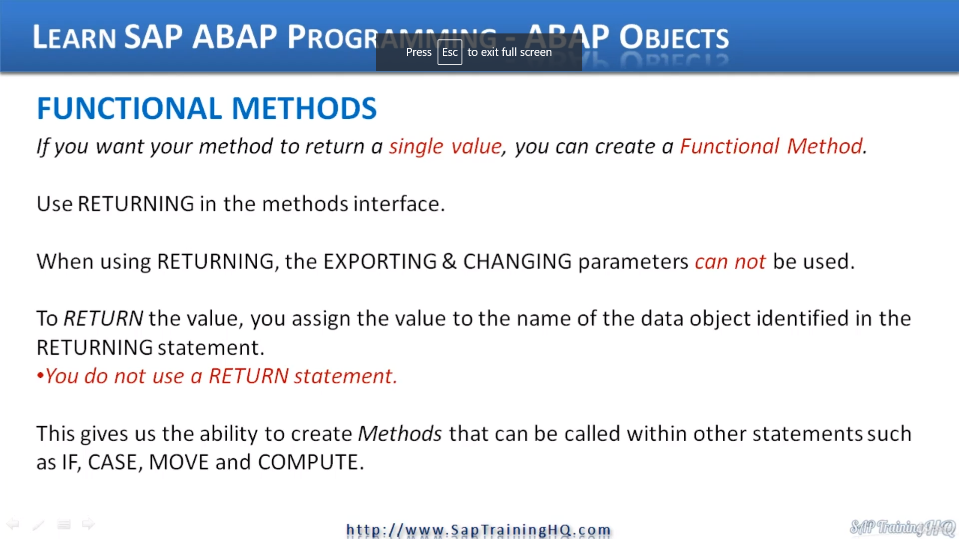

Now, at this stage, I want to discuss functional methods now, functional methods are a little bit different than normal methods in other subjects.

These are a specific type of method that are very useful for when we want to include a method call within logic, within our calling program.

Let me explain a bit more.

So, if you want your method to return a single value, let's say we want you to convert a number to a character string.

What we could do something like my text equals and then call the method.

So, you see what including the method call within a different about statement. So, what this allows us to do is make our method return a single value in line with our ABAP statements. so, we can reduce the amount of coding we have to do.

So as a quick overview, when we're creating functional methods that just a few rules that you need to bear in mind, we use the returning key word in the methods interface.

When we use the returning Keyword, the exporting and changing parameters can no longer be used. So, this is one of the rules of a functional method.

We use returning and we can't use exporting and changing to return the value back to our calling program. You assign the value to the name of the data object that you identified in the returning statement.

Note you do not use the return statement itself.

And like I mentioned, this gives us the ability to create methods that can be called within other statements.

And I've got some examples here. So, you could use the if statement, the case to move computes and so on.